Project Design Phase-II
Technology Stack (Architecture & Stack)

Date | 25 September 2026
Team ID | 6ab4dd426603573ccfb5912f
Project Name | AI Blog Nest API
Maximum Marks | 4 Marks

Technical Architecture:
The Deliverable shall include the architectural diagram as below and the information as per the table1 & table 2
AI BlogNest API – Technical Architecture
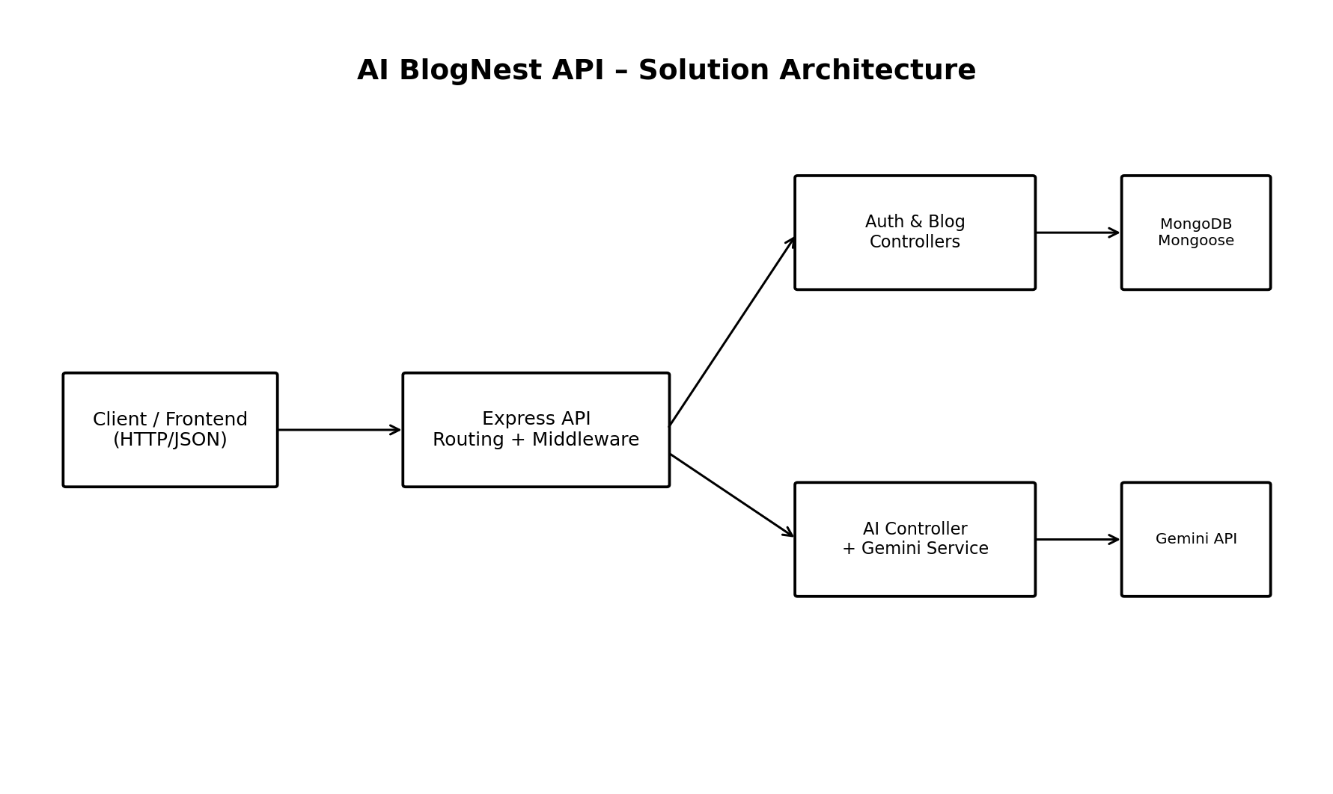
Figure 1: AI BlogNest API technical architecture. The architecture follows a layered backend approach. HTTP requests enter through Express, routes connect requests to controllers, middleware performs validation/authentication, controllers coordinate business logic, Mongoose handles persistence, and the Gemini service handles AI generation. Environment variables provide deployment-specific configuration.
Table-1 : Components & Technologies:
S.No | Component | Description | Technology
 | User Interface / API Client | Consumes REST endpoints and sends JSON requests. | Thunder Client / Postman or a web frontend
 | Application Logic-1 (HTTP API Layer) | Defines the REST endpoints and middleware pipeline. | Node.js + Express.js
 | Application Logic-2 (Core Logic) | Authentication, blog CRUD, AI generation and summarization. | JavaScript controllers / services
 | Application Logic-3 (Validation) | Checks request body fields before controller execution. | express-validator
 | Database | Stores users and blogs with timestamps and references. | MongoDB + Mongoose
 | Cloud Database
 | File Storage
 | External API-1 | Generates blog content and summaries. | Google Gemini via @google/generative-ai
 | External API-2
 | Machine Learning Model | AI blog generation and summarization are delegated to the external Gemini service. | Google Gemini (external service)
 | Infrastructure (Server / Cloud) | Runs as a Node.js server; default supplied configuration is http://localhost:5000. Cloud deployment infrastructure is not defined in the supplied files. | Local Node.js server; Cloud: [Information Not Provided]
 | Authentication | Issues and verifies signed access tokens. | jsonwebtoken / JWT
 | Password Security | Hashes passwords before storage and compares login credentials. | bcryptjs
 | Configuration | Loads environment variables for port, database, JWT and Gemini settings. | dotenv
 | Logging | Logs HTTP requests in development/server output. | morgan
 | Cross-Origin Support | Enables CORS handling for API access. | cors

Table-2: Application Characteristics:
S.No | Characteristics | Description | Technology
 | Open-Source Frameworks | Node.js/Express backend with modular JavaScript components. | Express, Mongoose, express-validator
 | Security Implementations | Hashed passwords, JWT verification, protected routes and environment secrets. | bcryptjs, jsonwebtoken, dotenv
 | Scalable Architecture | Separated routes/controllers/services/models permit feature expansion. | MVC-oriented modular structure
 | Availability | Application starts as a Node.js server and connects to MongoDB. | Node.js + MongoDB
 | Performance | JSON middleware, direct Mongoose queries and external AI calls keep responsibilities separated. | Express + Mongoose + Gemini
 | Maintainability | Dedicated files for routes, controllers, models, middleware and AI service. | src/ folder structure

References:
https://c4model.com/
https://developer.ibm.com/patterns/online-order-processing-system-during-pandemic/
https://www.ibm.com/cloud/architecture
https://aws.amazon.com/architecture
https://medium.com/the-internal-startup/how-to-draw-useful-technical-architecture-diagrams-2d20c9fda90d

